**Test Analysis**

**Were Vincent O**

The scores and various percentages for each of the students



* **Frequency distribution and normal distribution**

1. ***Frequency distribution***

**-**The frequency distribution of the total points out of 19 for the exam is as follows



This table shows the distribution of students’ scores, indicating that most students scored around 15 points.

1. ***Normal distribution***

* Mean Score: 15.75
* Standard Deviation: 0.829

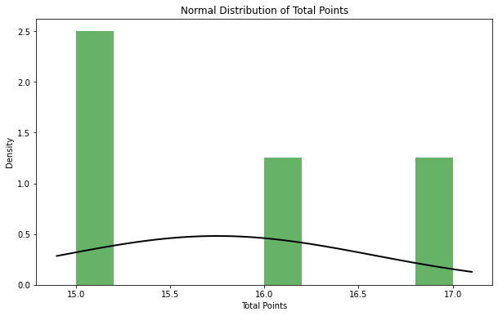

With a mean of *15.75* and a standard deviation of *0.829,* we can infer that the scores are tightly clustered around the mean, indicating relatively low variance.

* **Median**
* Median Score: ***15.5***

This shows that the middle score in the data set is 15.5, aligning closely with the mean, indicating a relatively symmetric distribution of scores(Adams & Khoo, 1993).

* **Standard deviation**

Standard Deviation: ***0.82915619758885.*** The standard deviation of 0.83 indicates that the scores of the students vary by approximately 0.83 points from the mean, suggesting relatively low variability in the exam results(Oermann et al, 2024).

* **Central Tendency**



Normal distribution as evidenced by mean and median having close values (Bastable, 2019, p. 227).

* **P level calculation**

Based on your provided data, the number of correct responses for each question can be computed from the responses of four students.



Desirable p-values- According to Bastable (2019), ideal p-values range from 0.30 to 0.70. The majority of the questions fall outside this range, with most being either too easy (p = 1.00) or too difficult (p = 0.00).

* T-Statistic: 1.5667
* P-Value: 0.2152

With a P-value of 0.2152, we cannot reject the null hypothesis, suggesting there is no significant difference in this set of scores from what would be expected under normal circumstances (Horne, 1995).

* **Discrimination index**



This table provides the discrimination index for each test item based on the performance of the upper and lower group of students. Values close to +0.20 and above indicate good discriminative power of the items (Matlock-Hetzel, 1997).

**Key Observations**

* Questions with valid discrimination indices show how well they distinguish between high and low scorers.
* A negative index (-0.17) may indicate that students with lower total scores answered the question correctly more often, suggesting potential issues with question clarity or content(Oermann et al, 2024).
* NaN values could arise due to incomplete data or if the question did not have enough variance in responses.
* **Mapping Exam Items to Learning Objectives**

To map a 20-item exam to learning objectives, Bloom’s taxonomy, and NCLEX categories, we will follow a structured approach:

1. ***Step 1: Map Exam Items to Learning Objectives***

Each question is designed to assess a specific learning objective in the context of nursing education. We align each question with key learning goals, such as understanding pathophysiology, clinical decision-making, or patient education (Moxley et al, 2017).

1. ***Step 2: Align Questions with Bloom's Taxonomy***

Bloom's taxonomy classifies learning objectives by cognitive complexity, ranging from simple recall to more complex analytical skills. We'll categorize questions using the following levels;

* Remembering- Recall facts and basic concepts.
* Understanding- Explain ideas or concepts.
* Applying- Use information in new situations.
* Analyzing- Draw connections among ideas.
* Evaluating- Justify a decision.
* Creating- Produce new or original work.

1. ***Step 3: Map to NCLEX Categories***

The NCLEX-RN exam is organized by categories that reflect areas of nursing practice. These categories include the following;

* Management of Care
* Safety and Infection Control
* Health Promotion and Maintenance
* Psychosocial Integrity
* Basic Care and Comfort
* Pharmacological and Parenteral Therapies
* Reduction of Risk Potential
* Physiological Adaptation

*Table: Mapping Questions to Learning Objectives, Bloom’s Taxonomy, and NCLEX Categories*

***DOUBLE CLICK TO VIEW TABLE***

* **Sample Exam Questions with Rationale**

1. ***Question 1-*** A patient with Type 2 diabetes presents with chest pain and shortness of breath. Which cardiovascular complication should the nurse monitor for?

*Rationale-* This question assesses the student's ability to identify critical cardiovascular risks, an essential skill in managing diabetic patients. It aligns with the objective of evaluating clinical decision-making skills.

1. ***Question 2-*** Multiple-Response: Select all that apply. Which lifestyle modifications should be recommended to reduce cardiovascular risks in a patient with diabetes?

*Rationale-* This question tests the application of knowledge regarding lifestyle interventions for diabetes management. Students must demonstrate understanding and apply it to clinical situations.

1. ***Question 3-*** When managing a patient with uncontrolled Type 2 diabetes, which cardiovascular complication poses the highest risk?

*Rationale-* This question evaluates the student's ability to prioritize high-risk complications, ensuring they understand the hierarchy of care in diabetic emergencies.

1. ***Question 4-*** A diabetic patient with coronary artery disease requires a care plan. Which of the following should be included?

*Rationale-* This question requires students to create a comprehensive care plan, testing higher-level cognitive skills like synthesis and application of knowledge.

1. ***Question 5-*** What is the primary difference between Type 1 and Type 2 diabetes regarding cardiovascular risks?

*Rationale-* By assessing the student's ability to differentiate between types of diabetes, this question targets understanding and comprehension.

1. ***Question 6-*** Which pharmacological treatment is typically used to manage cholesterol in diabetic patients to reduce cardiovascular risk?

*Rationale-* This question tests the student’s recall of common pharmacological interventions, a foundational aspect of diabetic care.

**References**

Adams, R. J., & Khoo, S. T. (1993). Quest: The interactive test analysis system.

Horne, R. N. (1995). Modern well test analysis. *Petroway Inc*, *926*, 987.

Oermann, M. H., Gaberson, K. B., & De Gagne, J. C. (2024). *Evaluation and testing in nursing education*. Springer Publishing Company.

Matlock-Hetzel, S. (1997). Basic Concepts in Item and Test Analysis.

Moxley, E., Maturin, L., & Rakstang, K. (2017). NCLEX-RN® success: An integrative lesson plan. *Teaching and Learning in Nursing*, *12*(2), 161-164.